Significance of Toll-like receptor 4 ( TLR4 )& liver fatty acid-
binding protein (L-FABP) expression in Hepatocellular carcinoma:
an immunohistochemical study.
Abstract
Back ground: Persistent inflammatory conditions can induce tumorigenesis . It is therefore very important to explore the molecular mechanisms involved in progression from chronic hepatitis to cirrhosis to HCC - to identify factors useful for the development of effective therapies that improve patient survival .
Aim of the study : Evaluation of TLR-4 and L-FABP expression in cases of chronic hepatitis, cirrhosis and HCC and correlate them with clinicopathological parameters.
Methods: A retrospective , immunohistochemical study was performed on 50 liver cases;32 cases of HCC, 10 cases of Chronic hepatitis C, and 8 cases of cirrhosis.
Results: There was statistical significant increase in TLR-4 expression in HCC than both chronic liver hepatitis and cirrhosis(P<0.05 ). There was positive statistical significant correlation between TLR-4 expression and size & grade of HCC(P<0.05) . There was highly statistical significant decrease in L-FABP expression in HCC than both chronic liver hepatitis and cirrhosis (P< 0.001 ).
Conclusion:TLR-4 has a role in hepatocarcinogenesis as TLR-4 expression increased with progression from chronic hepatitis to cirrhosis to HCC. Increased TLR-4 expression associated with large tumor size and higher grade of HCC, so it may serve a tool for prognosis of HCC. L-FABP expression decreased with progression from chronic hepatitis to cirrhosis to HCC. so its downregulation may contribute in pathogenesis of HCC.
Key words: TLR-4, L-FABP, Hepatocellular carcinoma, chronic hepatitis C.
Abbreviations: Hepatocellular carcinoma (HCC), Toll-like receptor 4(TLR4), Liver-Fatty acid-binding proteins (L-FABP).

Introduction
Hepatocellular carcinoma (HCC) is the most common primary liver cancer globally, it is the sixth most common cancer and the third leading cause of cancer related death (1).
In Egypt, HCC is the fourth most common cancer and is the second cause of cancer mortality in both sexes . HCC contributes to 14.8% of all cancer mortality in Egypt (2).
Hepatocellular carcinoma (HCC) is a severe health problem worldwide , as it is Characterized by a high rate of recurrence and poor prognosis . Despite various treatment options, HCC is associated with a high mortality rate and remains an intractable illness (3).
Persistent inflammatory conditions can induce tumorigenesis . Hepatocellular carcinoma (HCC) is closely associated with chronic inflammatory liver diseases. . It is therefore very important to further explore the molecular mechanisms involved in progression from chronic hepatitis to cirrhosis to HCC to identify factors useful for the development of effective therapies that improve patient survival(4).
Toll-like receptors (TLRs) are a family of pattern-recognition receptors that play a critical role in the activation of the innate immune system by recognizing pathogen-associated molecular patterns (PAMPs)(5)
Toll-like receptor 4(TLR4) is one of the most intensively studied members of the TLR family. It is also expressed in several liver cells, such as hepatocytes, Kupffer cells, and hepatic stellate cells, which are associated with liver disease. Under normal circumstances, the expression of TLR4 is at a relatively low level, however, when the liver is damaged under pro-inflammatory conditions, TLR4 expression is upregulated (6).
To date experimental studies, show that TLR4 is expressed on several types of tumor cells and signaling via TLR4 may play an important role in carcinogenesis, metastasis and cancer progression . Lipopolysaccharides (LPS), an agonist of TLR4, induces the interaction of TLR4 with adaptor molecule MyD88, which in turn activates downstream NF-kB signaling pathways subsequently causing inflammatory mediator production and promotion of HCC cell survival and proliferation ( 7).
Fatty acid-binding proteins (FABPs) bind and sequester potentially toxic long-chain fatty acids in the cytosol so that they may be rapidly removed via oxidative or storage organelles (8)
Liver-FABP (L-FABP or FABP1) is the first of the FABPs to be described so far. It is expressed in very high levels in liver, intestine and kidneys. FABP1 is positively regulated by hepatocyte nuclear factor 1 (HNF1α). While the downregulation of L-FABP expression is critically important in the diagnostic classification of HCA, and is correlated with various clinicopathological features,the significance of downregulation of L-FABP expression in HCC is largely unknown (9)
The present study aimed at evaluation of TLR-4 and L-FABP expression in chronic hepatitis, cirrhosis and HCC using immunohistochemical staining and relate their expression with clinicopathological data.
Material & Methods:
Study groups:
A retrospective study was performed on paraffin sections of 50 specimens of liver tissues including 10 specimens of chronic hepatitis C , and 8 specimens of cirrhosis and 32 specimens of HCC. In addition 6 specimens of normal liver core biopsy obtained from donors for liver transplantation were used as a control group. They were obtained from the departments of pathology, Faculty of Medicine, Benha University and National Liver Institute, Menofia University, during the period between March, 2010 and September, 2018. This research plan was approved by the Research Ethics Committee of Faculty of Medicine, Benha University, Egypt.
The following data were collected from the patient files: age, gender, alpha fetoprotein level (when available), presence or absence of hepatitis viral infection (HCV-RNA and HBV-DNA) by quantitative polymerase chain reaction and radiologic findings (Tumor focality, site and size).
All sections subjected to: Hematoxylin and eosin stain for histopathological assessment to confirm diagnosis and immunohistochemical staining for evaluation of TLR-4 and L-FABP expression.
Histopathological evaluation:
From each representative paraffin block of the studied cases, 4-μm thick sections were cut, stained by haematoxylin and eosin (H&E) and re-evaluated to confirm the diagnosis and to assess the following: for chronic hepatitis cases (the grade of activity and stage of fibrosis using Metavir scoring system) (10) ,for HCC ( type (11), grade According to WHO classification of tumors of digestive system (12) , (High grades HCC confirmed to be HCC by positivity to HepPar-1 and Arginase-1) , stage according to American Joint Committee on Cancer (AJCC) uses tumor-node-metastasis (TNM) system 8th edition (13) and vascular invasion ).
Immunohistochemical evaluation:
Immunohistochemical (IHC) procedure was performed according to manufacturer's instructions , using Polyonoclonal Anti-TLR4 antibody (Cat. # YPA1054- Chongqing Biospes Co.,Ltd ,China) (50ul) and Polyonoclonal Anti- LFABP antibody (Cat. #YPA1296- Chongqing Biospes Co.,Ltd ,China) (0.1 ml ). at a dilution of 1:50, at room temperature overnight. Immunodetection was carried out using a standard labeled streptavidin-biotin system (Genemed, CA 94080, USA, South San Francisco). Antigen retrieval was done by using 10 mmol/L citrate monohydrate buffer (pH 6.0) and heating for 15 minutes in the microwave. Freshly prepared chromogen diaminobenzine (DAB, Envision TM Flex /HRP-Dako, REF K 8000) was used.
Negative & positive controls:
Normal gastric mucosa used as a positive control for TLR4 (14) , and normal intestinal mucosa used as a positive control For L-FABP (15) .
For negative controls, the primary antibody was replaced with a solution of BSA in phosphate-buffered saline (PBS).
‏Immunohistochemical assessment:
TLR4: positivity was considered when there was brownish cytoplasmic staining .The extent of TLR4 positive hepatocytes was assessed by evaluating the entirety of the tissue on each stained slide into: 1‏, < 25% of hepatocytes positive for TLR4; 2‏, 25%-75% of hepatocytes positive for TLR4; 3‏, >75% of hepatocytes positive for TLR4 (16).
L-FABP: positivity was considered when there was brownish cytoplasmic staining . interpreted the staining results, which were analyzed for the intensity and percentage of staining area by using Quick-score analysis, whereby scores (Q) were calculated as follows: Q = Percentage of positive cells (P) × Intensity (I); maximum Q = 300. The results were then graded according to the following criteria:1: Q = 0–99, weak staining; 2: Q = 100–199, moderate staining; 3: Q = 200–300, strong staining (17) .
Statistical analysis: Data were collected, tabulated and statistically analyzed using a personal computer with SPSS version 20, p value is Statistically significant when ≤0.05. Receiver-operating characteristic (ROC) curve was used to predict sensitivity, specificity and accuracy of immunohistochemical score.
Results
Histopathological examination of 50 liver cases showed 32 (64%) cases of Hepatocellular carcinoma (HCC), 10(20%) cases of Chronic hepatitis C, and 8 (16%) cases of cirrhosis. In addition 6 cases of normal liver tissues as a control group.
Clinicopathological results
For HCC cases, shown in table (2)
Immunohistochemical results
TLR4 expression:
-All cases of studied normal group were scored (+1).
-In chronic hepatitis group: There is a highly positive statistical significant relation between TLR-4 expression and grade of activity (p< 0.001) ,as TLR-4 score increase with sever activity. table (1),figure (1).

Table (1) : Scoring of TLR-4 in chronic hepatitis C cases regarding activity
TLR4 | 1+(n=4) |  | 2+(n=4) |  | 3+(n=2) |  | Statistical test (FET) | P value
 | No | % | No | % | No | %
Activity grades  A1  A2  A3 | 4  0  0 | 100  0.0  0.0 | 0  3  1 | 0.0  75.0  25.0 | 0  0  2 | 0.0  0.0  100 | 10.88 | 0.004**
TLR-4=Toll like receptor-4, NO=number, FET=fishers exact test ,P=probability
-In HCC group : There was positive statistical significant relation between TLR4 expression and size & grade of HCC (p< 0.05). There was statistical significant difference between TLR4 expression and Histopathological pattern (p< 0.05) table (2), figure (2).
-There was statistical significant increase in TLR4 expression with progression from chronic hepatitis to cirrhosis to HCC . table (3).
Table (2) :Relation between TLR-4 expression and clinicohisto pathological data of HCC

TLR4  HCC | 1+(n=1) |  | 2+(n=16) |  | 3+(n=15) |  | Statistical test (FET) | P value
 | No | % | No | % | No | %
Age  Median (IQR) | 56.0(56.0-56.0) |  | 55.0 (47.2-60.7) |  | 56.0 (54.0-67.0) |  | KW= 1.6 | 0.45
Sex  Male  Female | 1  0 | 100  0.0 | 12  4 | 75.0  25.0 | 12  3 | 80.0  20.0 | 0.65 | 1.0
Aetiology  HCV  HBV | 1  0 | 100  0.0 | 15  1 | 93.8  6.3 | 15  0 | 100  0.0 | 2.69 | 1.0
AFP Median (IQR) | 300 |  | 335(250-537.5) |  | 600(300-1000) |  | KW= 3.95 | 0.14
Focal lesion  Single  Multiple | 1  0 | 100  0.0 | 13  3 | 81.3  18.8 | 13  2 | 86.7  13.3 | 3.54 | 0.26
Site  Rt lobe  Lt lobe  Both | 1  0  0 | 100  0.0  0.0 | 8  7  1 | 50.0  43.8  6.3 | 8  5  2 | 53.3  33.3  13.3 | 2.42 | 0.88
Size Median (IQR) | 2.0 |  | 3.0(2.0-4.5) |  | 4.5(3.5-6.0) |  | KW= 7.49 | 0.024*
Histopathological pattern  Clear  Solid  Trabecular  Trab+acina | 0  0  0  1 | 0.0  0.0  0.0  100 | 3  0  10  3 | 18.8  0.0  62.5  18.8 | 0  6  6  3 | 0.0  40.0  40.0  20.0 | 13.55 | 0.01*
Grade  Well differentiated  Moderate differentiated  Poorly differentiated  Undifferentiated | 0  1  0  0 | 0.0  100  0.0  0.0 | 5  8  3  0 | 31.2  50.0  18.8  0.0 | 1  4  6  4 | 6.7  26.7  40.0  26.7 | 10.76 | 0.048*
Grade  Low grade  High grade | 1  0 | 100  0.0 | 13  3 | 81.2  18.8 | 5  10 | 33.3  66.7 | 7.82 | 0.01*
Vascular invasion  Yes  No | 1  0 | 100  0.0 | 5  11 | 31.3  68.8 | 8  7 | 53.3  46.7 | 2.75 | 0.21
Stage  T1  T2  T3  T4 | 0  0  0  1 | 0.0  0.0  0.0  100 | 4  6  5  1 | 25.0  37.5  31.3  6.3 | 1  5  8  1 | 6.7  33.3  53.3  6.7 | 7.89 | 0.23
Stage  Early stage  Advanced stage | 0  1 | 0.0  100 | 10  6 | 62.5  37.5 | 6  9 | 40.0  60.0 | 2.50 | 0.29
L-FABP  1+  2+  3+ | 1  0  0 | 100  0.0  0.0 | 5  11  0 | 31.3  68.8  0.0 | 11  3  1 | 73.3  20.0  6.7 | 10.22 | 0.018*
TLR-4=Toll like receptor-4, No =Number, , AFP= Alpha fetoprotein, HCC= Hepatocellular carcinoma, FET=Fishers Exact test, P=probability, KW= kruskal wallis.
table (3) ): Comparison between and chronic hepatitis C, cirrhosis and HCC groups regarding TLR-4 expression
TLR4  expression | HCC (32) |  | Cirrhosis (8) |  | Hepatitis (10) |  | Statistical test (FET) | P value
 | No | % | No | % | No | %
Score 1+  Score 2+  Score 3+ | 1  16  15 | 3.1  50.0  46.9 | 0  2  6 | 0.0  25.0  75.0 | 4  4  2 | 40.0  40.0  20.0 | 9.57 | 0.015*
NO=Number ,TLR-4=Toll like receptor-4, HCC=hepatocellular carcinoma, FET=fishers exact test, , P=probability

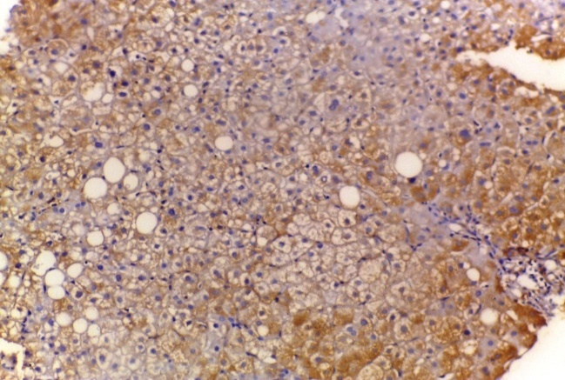
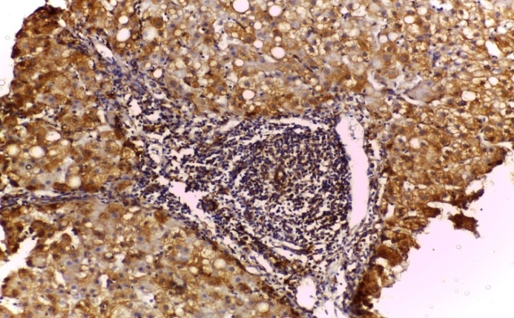
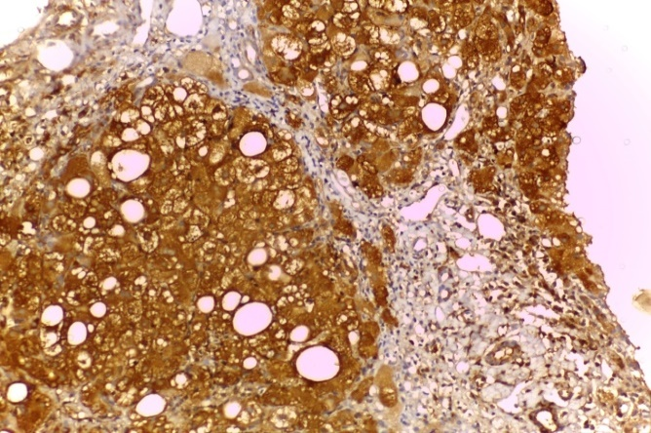
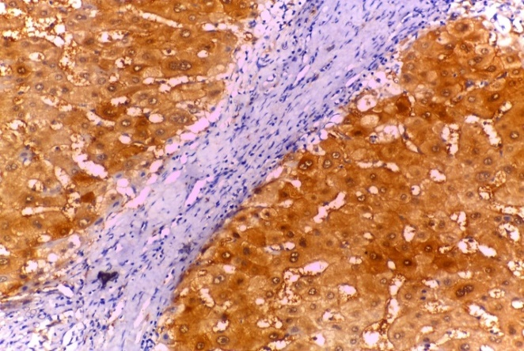
D text here
A text here

B text here

C text here

Figure (1 ): A) case of chronic hepatitis with mild activity (A1)and mild fibrosis(F1) showing positive cytoplasmic TLR-4 expression score (1+) (IHC x200).B) case of chronic hepatitis with moderate activity (A2)and moderate fibrosis(F2) showing positive cytoplasmic TLR-4 expression score (2+) (IHC x200).C) case of chronic hepatitis with sever activity (A3)and fibrosis(F3) showing positive cytoplasmic TLR-4 expression score (3+) (IHC x200).D) case of cirrhosis showing positive cytoplasmic TLR-4 expression score (3+) (IHC X200)

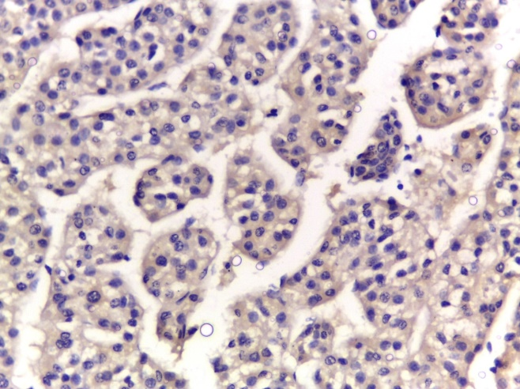
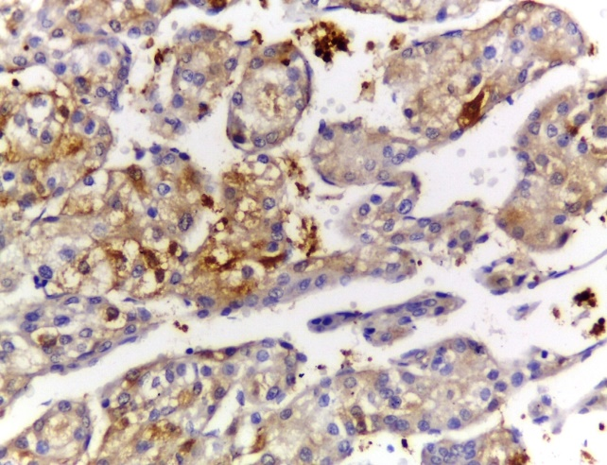
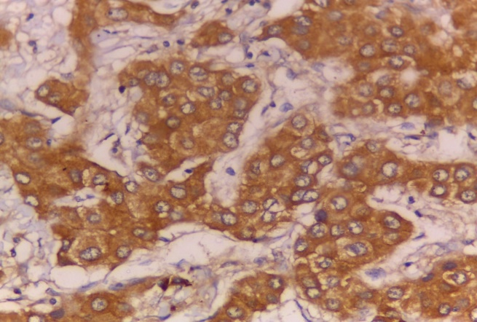
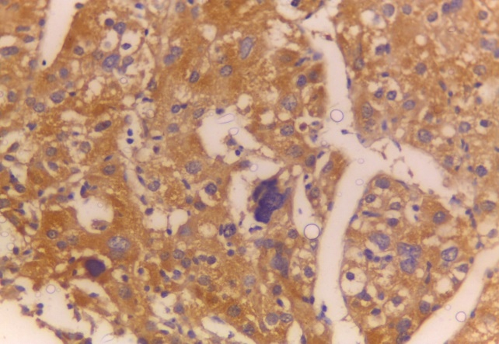
Aour text here
B text here

C text here

D text here

Figure(2):A) case of well differentiated HCC showing cytoplasmic TLR-4 expression score (2+) (IHC x400),B) case of moderately differentiated HCC with cytoplasmic TLR-4 expression score (2+) (IHC x400),C) case of poorly differentiated hepatocellular carcinoma showing cytoplasmic TLR-4 expression score (3+) (IHC x400),D) case of undifferentiated hepatocellular carcinoma showing cytoplasmic TLR-4 expression score (3+) (IHC x400)

L-FABP expression:
-All cases of studied normal group were scored (+3).
- There was highly statistical significant decrease in L-FABP expression with progression from chronic hepatitis to cirrhosis to HCC (p< 0.001) ,table (5), figure (3&4).
-There was no statistical significant relation between L-FABP expression and clinicopathological parameters of HCC table (4).

Table (4) ):Relation between L-FABP expression and clinicohisto pathological data of HCC

L-FABP  HCC | 1+(n=17) |  | 2+(n=14) |  | 3+(n=1) |  | Statistical test (FET) | P value
 | No | % | No | % | No | %
Age  Median (IQR) | 56 (54.5-65) |  | 53 (44-62) |  | 55(55-55) |  | KW= 3.09 | 0.21
Sex  Male  Female | 12  5 | 70.6  29.4 | 12  2 | 85.7  14.3 | 1  0 | 100  0.0 | 1.43 | 0.54
Aetiology  HCV  HBV | 17  0 | 100  0.0 | 13  1 | 92.9  7.1 | 1  0 | 100  0.0 | 2.97 | 0.47
AFP Median (IQR) | 450(315-1000) |  | 300(237.5-562.5) |  | 500 |  | KW= 3.34 | 0.19
Focal lesion  Single  Multiple | 15  2 | 88.2  11.8 | 10  4 | 71.4  28.6 | 1  0 | 100  0.0 | 1.87 | 0.49
Site  Rt lobe  Lt lobe  Both | 8  8  1 | 47.1  47.1  5.9 | 8  4  2 | 57.1  28.6  14.3 | 1  0  0 | 100  0.0  0.0 | 3.12 | 0.73
Size Median (IQR) | 4.5(3.0-6.5) |  | 3.5(2.38-4.75) |  | 3.0 |  | KW= 2.18 | 0.34
Histopathology  Clear  Solid  Trabecular  Trab+acina | 1  5  8  3 | 5.9  29.4  47.1  17.6 | 2  1  7  4 | 14.3  7.1  50.0  28.6 | 0  0  1  0 | 0.0  0.0  100  0.0 | 5.21 | 0.63
Grade  Well differentiated  Mod. differentiated  Poorly differentiated  Undifferentiated | 2  6  5  4 | 11.8  35.3  29.4  23.5 | 4  6  4  0 | 28.6  42.9  28.6  0.0 | 0  1  0  0 | 0.0  100  0.0  0.0 | 6.65 | 0.36
Grade  Low grade  High grade | 8  9 | 47.1  52.9 | 10  4 | 71.4  28.6 | 1  0 | 100  0.0 | 2.48 | 0.35
Vascular inv  Yes  No | 10  7 | 58.8  41.2 | 4  10 | 28.6  71.4 | 0  1 | 0.0  100 | 3.5 | 0.15
Stage  T1  T2  T3  T4 | 2  4  10  1 | 11.8  23.5  58.8  5.9 | 3  6  3  2 | 21.4  42.9  21.4  14.3 | 0  1  0  0 | 0.0  100  0.0  0.0 | 7.46 | 0.29
Stage  Early stage  Advanced stage | 6  11 | 35.3  64.7 | 9  5 | 64.3  35.7 | 1  0 | 100  0.0 | 3.47 | 0.16
L-FABP=Liver- fatty acid binding protein,No =Number, , AFP= Alpha fetoprotein, HCC= Hepatocellular carcinoma, FET=Fishers Exact test, P=probability, KW= kruskal wallis..
Table (5) : Comparison between chronic hepatitis C, cirrhosis and HCC groups regarding L-FABP expression
L-FABP  expression | HCC (32) |  | Cirrhosis (8) |  | Hepatitis (10) |  | Statistical test (FET) | P value
 | No | % | No | % | No | %
1+  2+  3+ | 17  14  1 | 53.1  43.8  3.1 | 2  6  0 | 25.0  75.0  0.0 | 0  2  8 | 0.0  20.0  80.0 | 27.51 | <0.001**
NO=Number , L-FABP=Liver- fatty acid binding protein, HCC=hepatocellular carcinoma, FET=fishers exact test, , P=probability
Correlation between TLR4 and L-FABP:
-There was significant inverse relation between TLR4 and L-FABP regarding their expression in chronic hepatitis C , cirrhosis and HCC group(P<0.05 ). table (6).
table (6) :Correlation between TLR4 and L-FABP
L-FABP | rho | P value
TLR4 | -0.362 | 0.01*

ROC curve results:
Receiver-operating characteristic (ROC) curve was used to predict sensitivity, specificity and accuracy of TLR4 & L-FABP immunohistochemical score in hepatitis, Cirrhosis and HCC groups. Both TLR4 & L-FABP were equally in accuracy to differentiate HCC from Cirrhosis , Sensitivity was 53.1%, specificity was 75.0 % and accuracy was 57.5% as shown in table (7, 9).
While L-FABP was more accurate than TLR4 to predict hepatitis from Cirrhosis, accuracy was (88.9% vs 22.2%) as shown in table (8,10).
Receiver-operating characteristic (ROC) curve was used to predict sensitivity, specificity and accuracy of TLR4 & L-FABP immunohistochemical score to detect high grade HCC from low grade HCC. TLR4 was more accurate than L-FABP to detect high grade HCC from low grade HCC, accuracy was (75.0% vs 62.5%) as shown in table (11,12).

table (7) : Validity of TLR4 to predict HCC group from Cirrhosis one:

 | HCC (32) |  | Cirrhosis (8) |  | Statistical test (FET) | P value
 | No | % | No | %
TLR4  ≤2+  3+ | 17  15 | 53.1  46.9 | 2  6 | 25.0  75.0 | 1.06 | 0.24
AUC (95% CI) | 0.641 (0.432-0.849)
Cut off point | 2+
Sensitivity | 53.1
Specificity | 75.0
PPV | 89.5
NPV | 28.6
Accuracy | 57.5

AUC, area under the curve; PPV, positive predictive value; NPV, negative predictive value.

table (8) : Validity of TLR4 to predict Cirrhosis group from hepatitis one:
 | Cirrhosis (8) |  | Hepatitis (10) |  | Statistical test (FET) | P value
 | No | % | No | %
TLR4  ≤2+  3+ | 2  6 | 25.0  75.0 | 8  2 | 80.0  20.0 | 3.45 | 0.054
AUC(95% CI) | 0.225 (0-0.456)
Cut off point | 2+
Sensitivity | 25.0
Specificity | 20.0
PPV | 20.0
NPV | 25.0
Accuracy | 22.2

AUC, area under the curve; PPV, positive predictive value; NPV, negative predictive value.
table (9) : Validity of L-FABP to predict HCC group from Cirrhosis one:
 | HCC (32) |  | Cirrhosis (8) |  | Statistical test (FET) | P value
 | No | % | No | %
L-FABP  1+  ≥2+ | 17  15 | 53.1  46.9 | 2  6 | 25.0  75.0 | 1.06 | 0.24
AUC (95% CI) | 0.641 (0.432-0.849)
Cut off point | 1+
Sensitivity | 53.1
Specificity | 75.0
PPV | 89.5
NPV | 28.6
Accuracy | 57.5
AUC, area under the curve; PPV, positive predictive value; NPV, negative predictive value.
table (10) : Validity of L-FABP to predict Cirrhosis group from hepatitis one:
 | Cirrhosis (8) |  | Hepatitis (10) |  | Statistical test (FET) | P value
 | No | % | No | %
L-FABP  ≤2+  3+ | 8  0 | 100  0.0 | 2  8 | 20.0  80.0 | 0.85 | 0.18
AUC (95% CI) | 0.625 (0.352-0.898)
Cut off point | 2+
Sensitivity | 100
Specificity | 80.0
PPV | 80.0
NPV | 100
Accuracy | 88.9
AUC, area under the curve; PPV, positive predictive value; NPV, negative predictive value.

table (11) : Validity of TLR4 to predict high grade HCC group from low grade one:
 | High grade (13) |  | Low grade (19) |  | Statistical test (x2) | P value
 | No | % | No | %
TLR4  3+  ≤2+ | 10  3 | 76.9  23.1 | 5  14 | 26.3  73.7 | 7.94 | 0.005**
AUC (95% CI) | 0.753 (0.575-0.931)
Cut off point | 3+
Sensitivity | 76.9
Specificity | 73.7
PPV | 66.7
NPV | 82.4
Accuracy | 75.0
AUC, area under the curve; PPV, positive predictive value; NPV, negative predictive value.

table (12) : Validity of L-FABP to predict high grade HCC group from low grade one:
 | High grade (13) |  | Low grade (19) |  | Statistical test (x2) | P value
 | No | % | No | %
FABP1  ≤2+  3+ | 9  4 | 69.2  30.8 | 8  11 | 42.1  57.9 | 2.28 | 0.13
AUC (95% CI) | 0.636 (0.438-0.833)
Cut off point | 2+
Sensitivity | 69.2
Specificity | 57.9
PPV | 52.9
NPV | 73.3
Accuracy | 62.5
AUC, area under the curve; PPV, positive predictive value; NPV, negative predictive value.

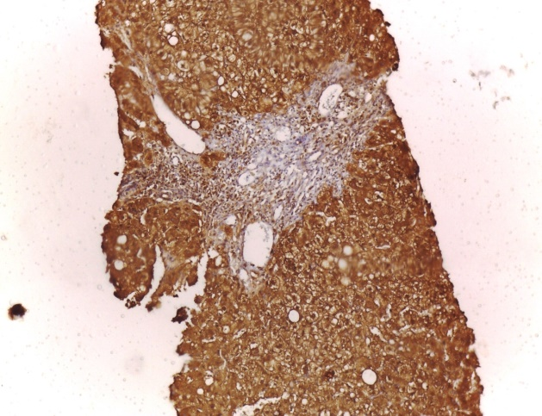
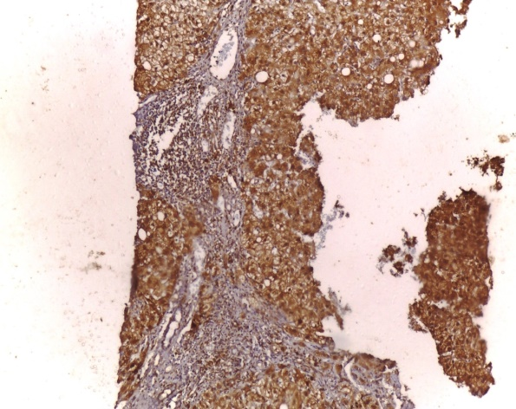
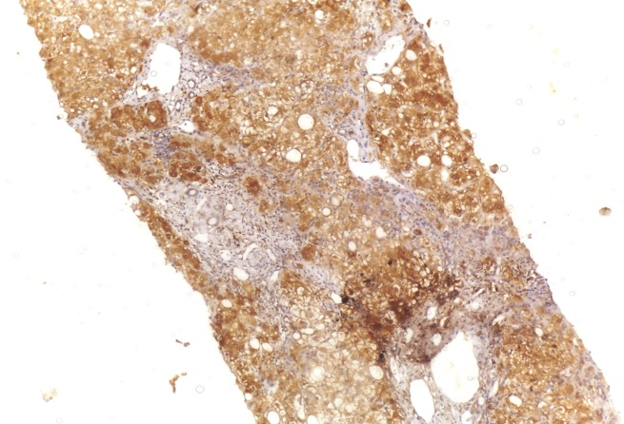
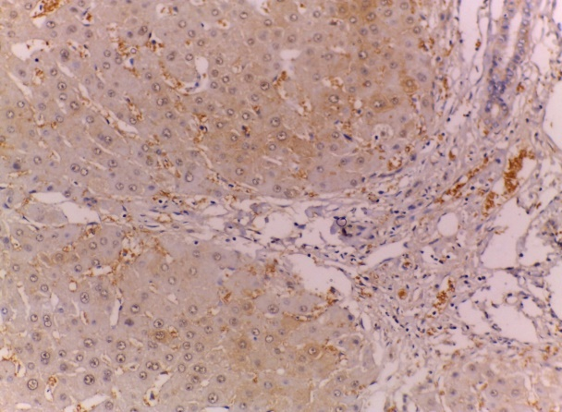
A text here

B text here

C text here

D text here

Figure ( 3):A)case of chronic hepatitis with mild activity (A1)and mild fibrosis(F1) showing positive cytoplasmic L-FABP expression score (3+) (IHC x100).B) case of chronic hepatitis with sever activity (A2)and fibrosis(F2) showing positive cytoplasmic L-FABP expression score (3+) (IHC x100).C) case of chronic hepatitis with sever activity (A3)and fibrosis(F3) showing positive cytoplasmic L-FABP expression score (2+) (IHC x100).D) case of cirrhosis showing positive cytoplasmic L-FABP expression score (2+) (IHC X200)

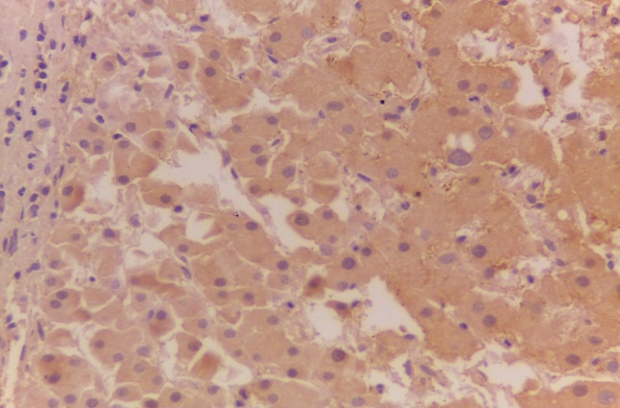
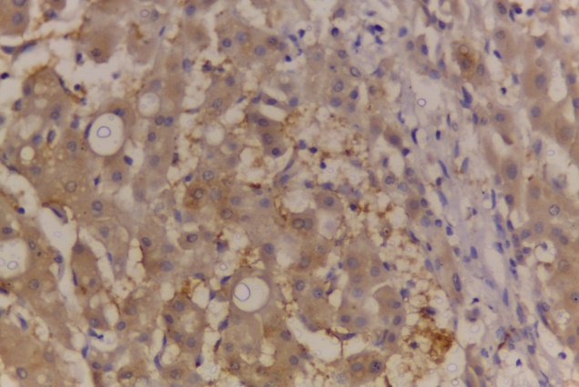
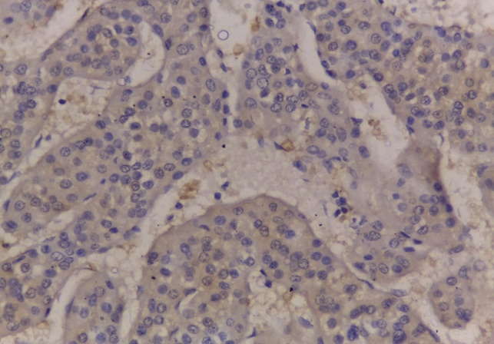
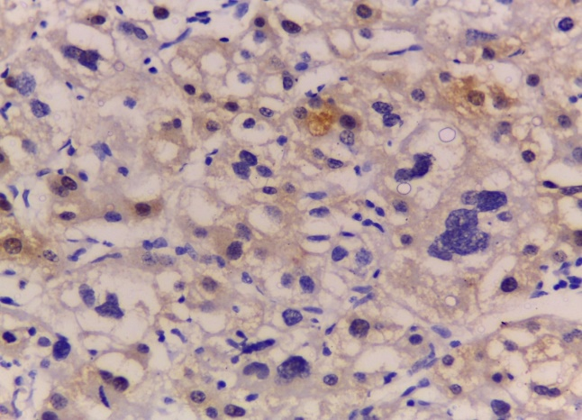
A text here

B text here

C text here

D text here

Figure(4):A) case of well differentiated HCC showing cytoplasmic L-FABP expression score (2+) (IHC x400).B) case of moderately differentiated HCC showed cytoplasmic L-FABP expression score (2+) (IHC x400).C) case of poorly differentiated HCC (grade III) showing cytoplasmic L-FABP expression score (1+) (IHC x400).D) case of undifferentiated HCC (grade IV) showing cytoplasmic L-FABP expression score (1+) (IHC x400)

Discussion:
During recent years, evidence has been accumulating to show that inflammation has an important role in initiation, promotion, and progression of tumors .The generation of pro-inflammatory cytokines in the tumor microenvironment provokes activation of NF-κB in cancer cells, leading to protection against pro-apoptotic host immune defense mechanisms .It has been shown that cytokines and growth factors produced by tumor-infiltrating macrophages, lymphocytes, and other cell types in the inflammatory tumor microenvironment influence cell differentiation and exert antiapoptotic and proangiogenic effects which stimulate the growth of cancer cells, tumor invasiveness, and metastasis (18).
Hepatocarcinoma (HCC), a prominent example for inflammation-associated cancer, is a major complication in the end-stage of cirrhosis . In most cases, HCC in humans is the outcome of continuous injury and chronic inflammation; thus, it provides a good and realistic inflammatory-related cancer model to gain insight about the role of TLR4 in the carcinogenesis( 4)
Toll-like receptor 4(TLR4) is one of the most intensively studied members of the TLR family. Lipopolysaccharides (LPS), an agonist of TLR4, induces the interaction of TLR4 with adaptor molecule MyD88, which in turn activates downstream NF-kB signaling pathways subsequently causing inflammatory mediator production and promotion of HCC cell survival and proliferation ( 7).
In this study, TLR4 expression in control group was detected in cytoplasm of hepatocytes score (+1) . This agreed with Soares et al.,( 18) who found that Under normal circumstances, the expression of TLR4 is at a relatively low level, however, when the liver is damaged under pro-inflammatory conditions , TLR4 expression is upregulated .
There was highly positive statistical significant correlation between TLR-4 expression and grade of activity, this agreed with Wei et al., (19) who found positive correlation between the staining scores of TLR4 expression and the grading scores in CHB.
In the present study, there was positive statistical significant correlation between scoring of TLR-4 expression and size of HCC (p< 0.05) . In agreement with our results González-reyes et al., (20) ) and SHi et al., (21) revealed that high expression of TLR-4 was associated with a large tumor size in breast cancer.
In the current study, there was statistical significant difference between scoring of TLR-4 expression and Histopathological pattern of HCC (p< 0.05) . This is in agreement with Wang et al., (22 ) who observed that TLR4 expression was significantly associated with histologic type.
Also it is found a positive statistical significant correlation between scoring of TLR-4 expression and grade of HCC (p< 0.05) ,Which is in concorance with Kang et al., (23) who observed that TLR4 expression level was correlated with the degree of tumor differentiation and TNM stage in HCC. They explained this by TLR4/MyD88 pathway mediates the activation of NF-κB and subsequent production of pro-inflammatory cytokines, including IL-1β, IL-6 and TNF-α. These cytokines stimulate myeloid dendritic cells to secret IL-23, which promotes Th17 cell differentiation, proliferation and maintenance.
Soares etal.,(24) found that immunohistochemistry confirmed increased expression of TLR2 and TLR4 in hepatitis and cirrhosis and maintained expression in hepatocarcinoma. Upregulation of TLR2, TLR4 and their proinflammatory mediators is associated with virus-induced hepatic IFC sequence. Our results confirmed their findings as there was statistical significant increase in TLR-4 expression with progression from normal to chronic hepatitis C to cirrhosis to HCC group (P<0.05 ).
Liver-FABP (L-FABP) is the first of the FABPs to be described. It is bind and sequester potentially toxic long-chain fatty acids in the cytosol so that they may be rapidly removed via oxidative or storage organelles.It is expressed in very high levels in liver, intestine and kidneys. FABP1 is positively regulated by hepatocyte nuclear factor 1 (HNF1α) (9)
As regard L-FABP expression in control group, it was detected in cytoplasm of hepatocytes score (+3) . This agreed with Lawrie et al.,(25) who found that L-FABP showed high expression in normal colon and loss of its expression in colorectal cancer .
Regarding L-FABP expression in chronic hepatitis C cases: L-FABP expression was were scored (2+) in 20% and 80% were scored as(3+) . As regard expression in cirrhosis group, 25% of cases were scored as (1+) and 75% were scored as(2+) . In HCC cases, 53.1% was scored (1+) , 43.8% were scored (2+) and 3.1% were scored (3+) . This is in agreement with Cho et al.,(26)with who found that expression of L-FABP is downregulated in cirrhosis and HCC. He also observed that a greater proportion of moderately and poorly differentiated HCC showed complete loss of LFABP . It is possible that L-FABP loss may be associated with these morphologic changes and thus may represent a pathway involved in HCC differentiation/carcinogenesis .
However, these results were in disagreement with KU et al.,( 27) who found that Liver Fatty Acid-Binding Protein (L-FABP) Promotes Cellular Angiogenesi And Migration In Hepatocellular Carcinoma. They found that L-FABP was highly expressed in HCC tissues, and this expression was positively correlated with that of VEGF-A. Additionally, L-FABP significantly promoted tumor growth and metastasis in a xenograft mouse model. We also assessed the mechanisms of L-FABP activity in tumorigenesis; L-FABP was found to associate with VEGFR2 on membrane rafts and subsequently activate pathways, which resulted in up-regulation of VEGF-A accompanied by an increase in both angiogenic potential and migration activity.
In the current study, there was highly statistical significant decrease in L-FABP expression with progression from normal to chronic hepatitis C to cirrhosis to HCC group (P<0.001) .This is in agreement with Inoue et al.,(28) who found that in HCC, L-FABP downregulation probably occurs because of phenotypic changes during tumor progression. Moreover, this downregulation correlated with tumor differentiation and intratumoral inflammation.
These results were in disagreement with Eguch et al.,( 29), Albadawy etal., (30) whom found that Serum Liver-Type Fatty Acid–BindingProtein is a Possible Prognostic Factor in Human Chronic Liver Diseases, increasing From Chronic Hepatitis to Liver Cirrhosis and Hepatocellular Carcinoma ,These difference due to their study was used on serological material and this increase in serum because its level in serum associate with tissue breackdown.
This study showed significant inverse relation between TLR4 and L-FABP regarding their expression in chronic hepatitis C , cirrhosis and HCC group(P<0.05 ). As TLR-4 expression increased with progression from normal to chronic hepatitis C to cirrhosis to HCC group,agreed with Soares etal.,(24) who found Increased hepatic expression of TLR2 and TLR4 in the hepatic inflammation-fibrosis-carcinoma sequence.While L-FABP expression decreased with progression from normal to chronic hepatitis C to cirrhosis to HCC group, agreed with Inoue et al.,(28) who found that in HCC, L-FABP downregulation probably occurs because of phenotypic changes during tumor progression .
In this study,using receiver-operating characteristic (ROC) ,found that both TLR4 & L-FABP were equally in accuracy to differentiate HCC from Cirrhosis , Sensitivity was 53.1%, specificity was 75.0 % and accuracy was 57.5%, While L-FABP was more accurate than TLR4 to predict hepatitis from Cirrhosis, accuracy was (88.9% vs 22.2%)
Also by using ROC curve ,TLR4 was more accurate than L-FABP to detect high grade HCC from low grade HCC, accuracy was (75.0% vs 62.5%).
Agreed with Hussein et al.,(31),who evaluated patients with HCV related HCC by using receiver-operator characteristic (ROC) curves of TLR2 and TLR4, we found AUC of TLR2 and TLR4 (0.72±0.06, 0.77±0.05 respectively) with high sensitivity specificity+ve Predictive value and -ve Predictive value so TLR2 and TLR4 have crucial role in pathogensis of HCV related HCC so these results raise the possibility that by targeting TLR2 and TLR4 with high affinity pharmacological stimulants may be able to control HCV infection by induction of IFN-α and direct activation of antiviral mechanisms in hepatocytes. Additionally, they provide insight about the potential use of them as a new set of molecular markers for prognosis and outcomes of chronic HCV infection and HCC and we hope to early stage recognition of HCC make these patients eligible for potentially curative therapies, as therapeutic targets for HCC by inhibiting TLRs with antagonists has the potential to be a novel therapeutic technique for HCCor TLR agonists as immune tolerance.
Albadawy et al.,(30)Analysis of ROC curve of serum FABP-1 revealed that FABP-1 at cut off values (214 ng/L) sensitivity was 60%, specificity was 77.5%, PPV was 72.7, NPV was 66% and AUC = 0.715. This came in agreement with Akbal et al.,(32) where it was reported that when a cut-off value was 29,0 ng/mL for FABP-1, sensitivity and specificity were 75 and 100%, respectively. Positive and negative predictive values for FABP-1 were 100 and 78%, respectively (3). These results indicate that serum FABP-1can be used as a new diagnostic marker to detect liver injury and can be used in the diagnosis of chronic liver diseases, including those coupled with HCC .
Conclusion:
TLR-4 has a role in hepatocarcinogenesis as TLR-4 expression increased with progression from chronic hepatitis to cirrhosis to HCC. Increased TLR-4 expression associated with large tumor size and higher grade of HCC, so it may serve a tool for prognosis of HCC. L-FABP expression decreased from chronic hepatitis to cirrhosis to HCC. so its downregulation may contribute in pathogenesis of HCC.These may useful for the development of effective therapies that improve patient survival.
Conflicts of interest:
No conflicst of interest.
References
- Petruzziello A. Epidemiology of hepatitis B virus (HBV) and hepatitis C virus (HCV) related hepatocellular carcinoma. Open Virol J. 2018; 12:26-32.
- Ozakyol A. Global Epidemiology of Hepatocellular Carcinoma ,J Gastrointest Cancer. 2017; 48:238-240 .
- Lopes Fde L, Coelho FF, Kruger JA, Fonseca GM, Araujo RL, Jeismann VB, et al . Influence of Hepatocellular Carcinoma Etiology in the Survival after Resection. Arq Bras Cir Dig. 2016; 29:105–108.
- Refolo MG, Messa C, Guerra V, Carr BI, D'Alessandro R. Inflammatory Mechanisms of HCC Development. Cancers (Basel). 2020 Mar 10;12(3):641.
- Zou H, Wang WK, Liu YL, Braddock M, Zheng MH, Huang DS. Toll-like receptors in hepatocellular carcinoma: potential novel targets for pharmacological intervention. Expert Opin Ther Targets. 2016 Sep; 20(9):1127-35.
- Kiziltas S. Toll-like receptors in pathophysiology of liver diseases. World J Hepatol. 2016 Nov 18;8(32):1354-1369.
- Liu WT, Jing YY, Yu GF, Han ZP, Yu DD, Fan QM,et al. Toll like receptor 4 facilitates invasion and migration as a cancer stem cell marker in hepatocellular carcinoma. Cancer Lett. 2015 Mar 28;358(2):136-143.
- Wang G, Bonkovsky HL, de Lemos A, Burczynski FJ. Recent insights into the biological functions of liver fatty acid binding protein 1. J Lipid Res. 2015 Dec;56(12):2238-47.
- Bioulac-Sage P, Balabaud C, Wanless I. Focal nodular hyperplasia and hepatocellular adenoma. In: Bosman FT, Carneiro F, Hruban RH, Theise ND. WHO classification of tumours of the digestive system. 4th ed. Lyon: International Agency for Research on Cancer, 2010: 198-204
- Sofue K, Onoda M, Tsurusaki M, Morimoto D, Yada N, Kudo M, et al. Dual‐frequency MR elastography to differentiate between inflammation and fibrosis of the liver: Comparison with histopathology. Journal of Magnetic Resonance Imaging. 2020; 51(4), 1053-1064.‏
- Okabe H, Yoshizumi T, Yamashita Y, Imai K , Hayashi H, Nakagawa S, et al. Histological architectural classification determines recurrence pattern and prognosis after curative hepatectomy in patients with hepatocellular carcinoma . PloS one. 2018; 13(9).
- Martins-Filho SN, Paiva C, Azevedo RS, Alves VAF. Histological Grading of Hepatocellular Carcinoma-A Systematic Review of Literature. Front Med (Lausanne). 2017 Nov 10;4:193.
- Amin BM , Greene LF, Edge BS, Compton C C, Gershenwald E J, Brookland K R, et al.The Eighth Edition AJCC Cancer Staging Manual: continuing to build a bridge from a population-based to a more “personalized” approach to cancer staging .CA Cancer J Clin .2017;67 (2):93-99
- Li N, Xu H, Ou Y, Feng Z, Zhang Q, Zhu Q, et al. LPS-induced CXCR7 expression promotes gastric Cancer proliferation and migration via the TLR4/MD-2 pathway. Diagnostic pathology. 2019; 14(1), 3.‏
- Derikx J P, Vreugdenhil A C, Van den Neucker A M, Grootjans J, van Bijnen A A, Damoiseaux J G.et al. A pilot study on the noninvasive evaluation of intestinal damage in celiac disease using I-FABP and L-FABP. Journal of clinical gastroenterology. 2009; 43(8), 727-733.‏
- Hayati AR, Mohamed AE , Tan GC. An immunohistochemical study of Toll-like receptors 2 and 4 in placenta with and without infection. Malaysian J Pathol 2010; 32(1) : 13 – 19.
- Ku CY, Liu YH, Lin HY, Lu SC , Lin JY. Liver Fatty Acid-Binding Protein (L-Fabp) Promotes Cellular Angiogenesi And Migration In Hepatocellular Carcinoma. Oncotarget.2016;7(14):18229-18245
- Soares JB, Pimentel-Nunes P, Roncon-Albuquerque R, Leite-Moreira A. The role of lipopolysaccharide/toll-like receptor 4 signaling in chronic liver diseases. Hepatol Int. 2010 Oct 21;4(4):659-72.
- Wei XQ, Guo YW, Liu JJ, Wen ZF, Yang SJ, Yao JL. The significance of Toll-like receptor 4 (TLR4) expression in patients with chronic hepatitis B. Clin Invest Med. 2008;31(3):E123-30.
- González-Reyes S, Marín L, González L, González LO, del casar JM, lamelas ML. Study of Tlr3, Tlr4 and Tlr9 in breast carcinomas and their association with metastasis. BMc cancer. 2010; 10: 665.
- Shi S, Xu C, Fang X, Zhang Y, Li H, Wen W, et al. Expression profile of Toll-like receptors in human breast cancer. Mol Med Rep. 2020 Feb;21(2):786-794.
- Wang EL, Qian ZR, Nakasono M, Tanahashi T, Yoshimoto K, Bando Y, et al. High expression of Toll-like receptor 4/myeloid differentiation factor 88 signals correlates with poor prognosis in colorectal cancer. Br J Cancer. 2010 Mar 2;102(5):908-15.
- Kang Y, Su G, Sun J, Zhang Y. Activation of the TLR4/MyD88 signaling pathway contributes to the development of human hepatocellular carcinoma
via upregulation of IL-23 and IL-17A. Oncol Lett. 2018 Jun;15(6):9647-9654.
- Soares JB, Pimentel-Nunes P, Afonso L, Rolanda C, Lopes P, Roncon-Albuquerque R Jr. Increased hepatic expression of TLR2 and TLR4 in the hepatic inflammation-fibrosis-carcinoma sequence. Innate Immun. 2012 Oct;18(5):700-8.
- Lawrie LC, Dundas SR, Curran S, Murray GI. Liver fatty acid binding protein expression in colorectal neoplasia. Br J Cancer. 2004 May 17;90(10):1955-60.
- Cho SJ, Ferrell LD, Gill RM. Expression of liver fatty acid binding protein in hepatocellular carcinoma. Hum Pathol. 2016 Apr;50:135-9.
- Ku CY, Liu YH, Lin HY, Lu SC , Lin JY. Liver Fatty Acid-Binding Protein (L-Fabp) Promotes Cellular Angiogenesi And Migration In Hepatocellular Carcinoma. Oncotarget. 2016;7(14):18229-18245
- Inoue M, Takahashi Y, Fujii T, Kitagawa M, Fukusato T. Significance of downregulation of liver fatty acid-binding protein in hepatocellular carcinoma. World J Gastroenterol. 2014 Dec 14;20(46):17541-51.
- Eguchi A, Hasegawa H, Iwasa M, Tamai Y, Ohata K, Oikawa T et al . Serum Liver-Type Fatty Acid–BindingProtein Is aPossible Prognostic Factor in Human Chronic Liver Diseases From Chronic Hepatitis to Liver Cirrhosis and Hepatocellular Carcinoma HepatologyCommuniCations . 2019 ; 39(6):825- 830.
- Albadawy R M, Abd El-Aziz B A, Behiry E G, Azzam M E. Assessment the Association of Fatty Acid Binding Protein 1 with Hepatocellular Carcinoma. Benha Medical Journal. 2020 January 19.
- Hussein R M, Abd El-Halim H, Shatat M, Allam E, Abd El-Gahny W , Tawfik H M. Relation Of Toll Like Receptor 2 And 4 To HCC Parameters . Research Journal of Pharmaceutical, Biological and Chemical Science.2019;10(3):469.
- Akbal E, Köklü S , Koçak E, Çakal B, Güneş F , Başar O. Liver Fatty Acid-Binding Protein Is A Diagnostic Marker To Detect Liver Injury Due To Chronic Hepatitis C Infection. Official Journal Of The Institute Mexicano Del Seguro Social. 2013; 44 (1): 34.38.

